Tab 1

### **Title: Add User-Friendly Notifications for the Newsletter Subscription Module**

### **Why:**

Currently, the newsletter subscription module works as expected from a technical standpoint but lacks feedback for users. This can lead to confusion, as users don't know whether their action succeeded or failed. Adding clear and user-friendly notifications will improve the user experience, ensure clarity, and make the module more interactive.

### **To-Do:**

1. Implement notifications for the following scenarios:
   * Successful subscription with a valid, unique email.
   * Attempt to subscribe with an invalid email format.
   * Attempt to subscribe with a duplicate email address.
2. Notifications should appear directly below the newsletter subscription input box.
3. Use colors and formatting to distinguish between success and error notifications.
4. Ensure the notifications disappear automatically after 5 seconds or when the user modifies the input.

### **Content:**

1. **Messages to display:**
   * **Success:**
     + Text: "Subscription successful! Thank you for subscribing to our newsletter."
     + Color: Green.
   * **Invalid Email Format:**
     + Text: "Please enter a valid email address."
     + Color: Red.
   * **Duplicate Email:**
     + Text: "This email address is already subscribed."
     + Color: Red.
2. **Location:**
   * Notifications should appear directly under the input box for email submission.
3. **Styling:**
   * Font: Match the website's default font style.
   * Visibility: Fade in when triggered and fade out automatically after 5 seconds.

## **VISUALS / WIREFRAMES**

Here is a simple wireframe of how the notifications should appear below the subscription box

### 

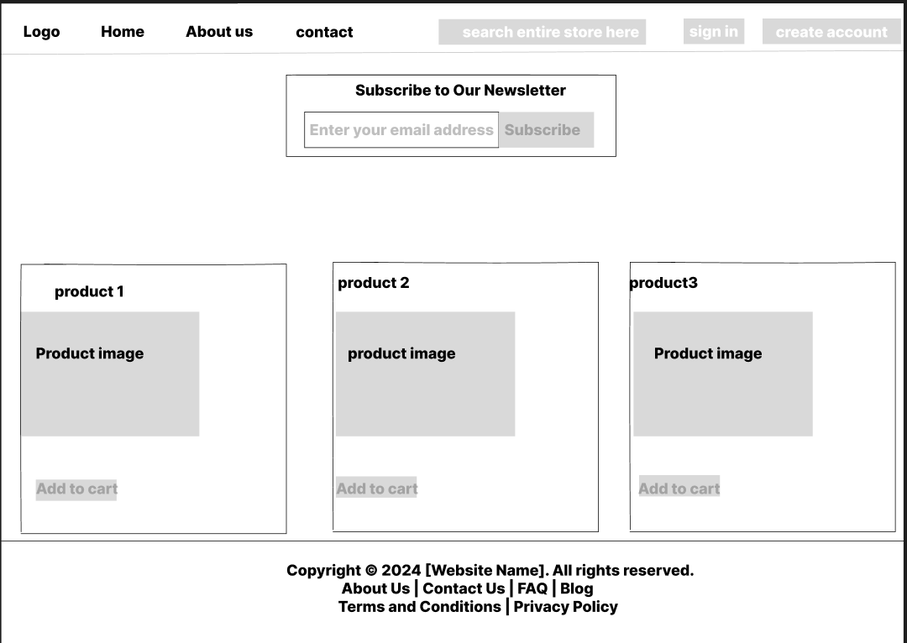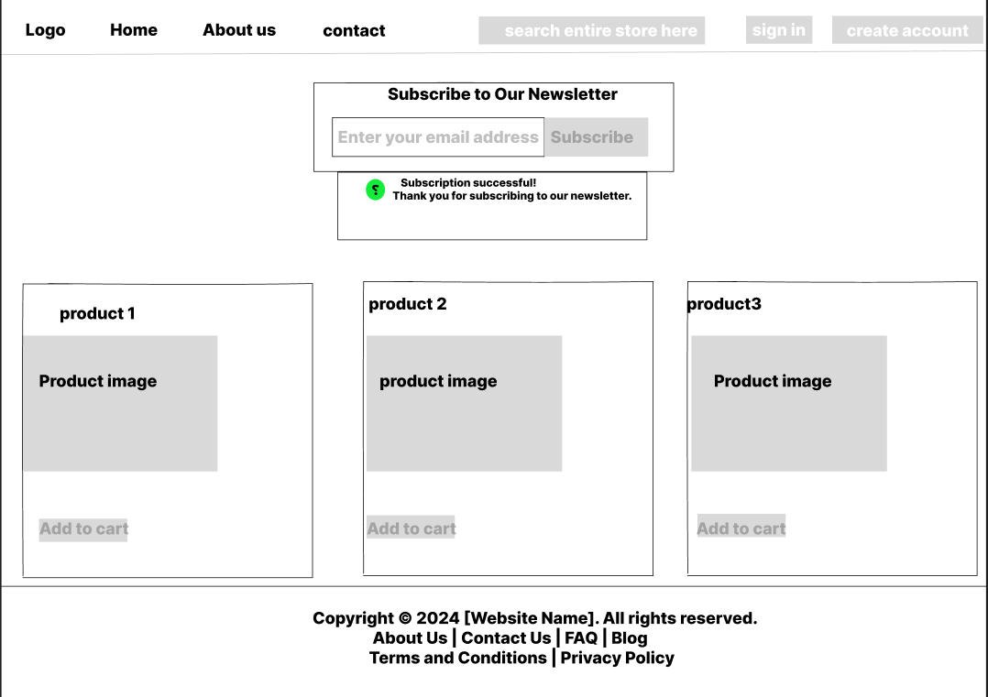

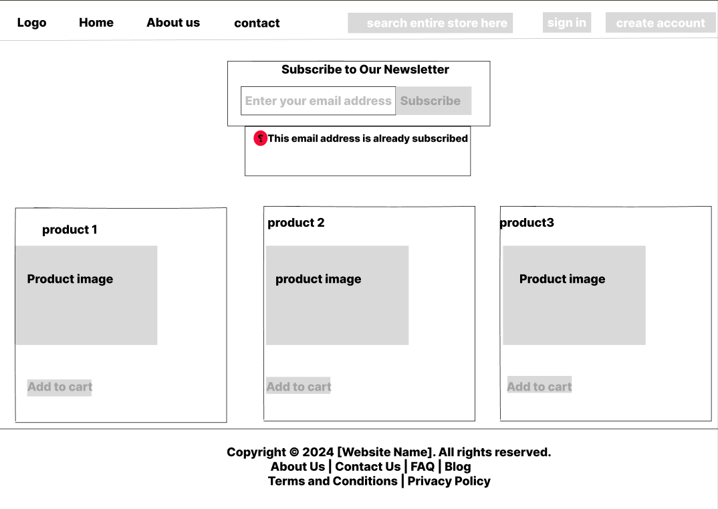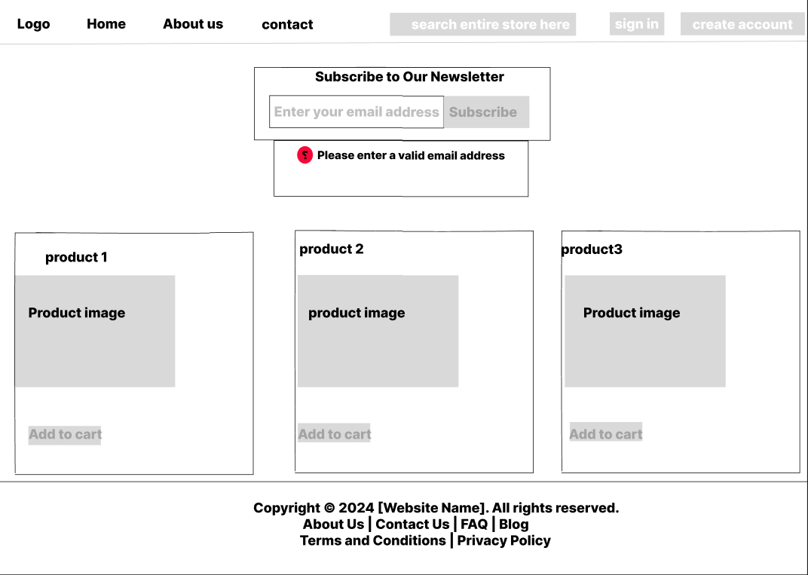

### 

### **How to Test:**

## Test Case 1: Successful Subscription

## Data: Use validate_test@gmail.com (not in the database).

## Steps:

## Enter the email in the subscription box.

## Click the "Subscribe" button.

## Expected Result:

## Email is added to the database.

## Notification appears: "Subscription successful! Thank you for subscribing to our newsletter."

## Notification disappears after 5 seconds.

## Test Case 2: Invalid Email Format

## Data: Use invalidate_test@gmail.com (incorrect format).

## Steps:

## Enter the email in the subscription box.

## Click the "Subscribe" button.

## Expected Result:

## No email is added to the database.

## Notification appears: "Please enter a valid email address."

## Notification disappears after 5 seconds.

## Test Case 3: Duplicate Email

## Data: Use already_subscribed@gmail.com (already in the database).

## Steps:

## Enter the email in the subscription box.

## Click the "Subscribe" button.

## Expected Result:

## No duplicate entry is added to the database.

## Notification appears: "This email address is already subscribed."

## Notification disappears after 5 seconds.

## Cross-Browser Testing:

## Test on Chrome, Firefox, Edge, and Safari to ensure compatibility.